- Follow this link, read the directions, and complete the activity. http://www.roguecc.edu/counseling/hollandcodes/test.asp

Each question is an opportunity for you to describe the kinds of things you can do, might like to do or the action that most fits you. When you have selected all of the choices that describe you, click "submit" to get your “Holland Code” and determine what career path(s) work best for you.

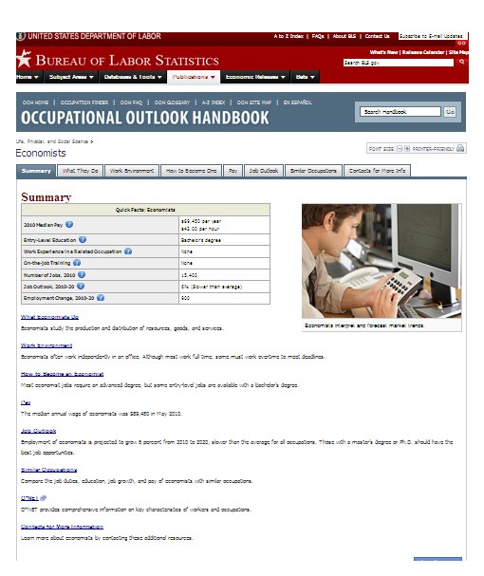
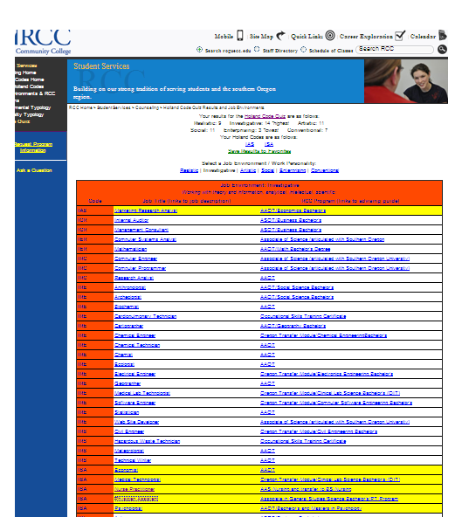
- When it gives you a list of jobs, read through the summary page for each job highlighted in yellow.

(If nothing is highlighted yellow, figure out how it got your code, and what your next closest code would be. For example: This screen shot shows “IAC” as the code because the scores for each letter are 13, 10, and 9, in that order. None of the jobs match that code exactly, so nothing is yellow. But this person could look for ICA, IAS, or ICS because “C”, “A”, and “S” are all very close.)

- Pick the 3 jobs you find most interesting and copy the “Summary Quick Facts” table onto a piece of paper, so the information is side-by-side.

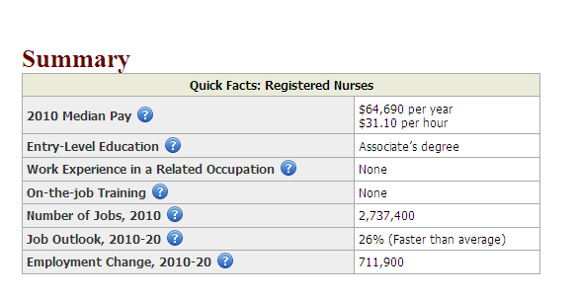
(Draw something like this on your paper.)
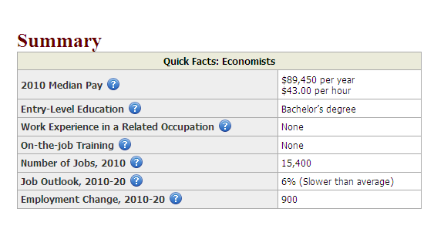
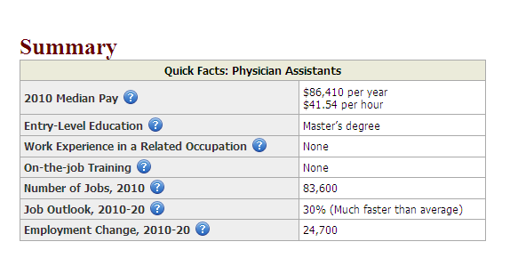
Economist

Now click on the tabs for your top choices and read more!

